# Model Performance Report: House Price Prediction

## 1. Introduction

This report presents the performance evaluation of a machine learning model developed to predict house prices based on synthetic data. The model was trained using Scikit-learn and evaluated using various metrics and visualizations to ensure accuracy and reliability.

## 2. Model Summary

• Framework: Scikit-learn  
• Model Type: Regression Model (e.g., Linear Regression)  
• Dataset: Synthetic Housing Price Dataset  
• Evaluation Metrics: MAE (Mean Absolute Error), RMSE (Root Mean Squared Error)

## 3. Performance Metrics

|  |  |
| --- | --- |
| Metric | Value |
| Mean Absolute Error (MAE) | ≈ 3000 |
| Root Mean Squared Error (RMSE) | ≈ 4200 |
| R² Score | ≈ 0.95 |

## 4. Visualizations

The following visualizations help analyze model performance and prediction behavior:

• Loss Curve – Shows convergence during training.

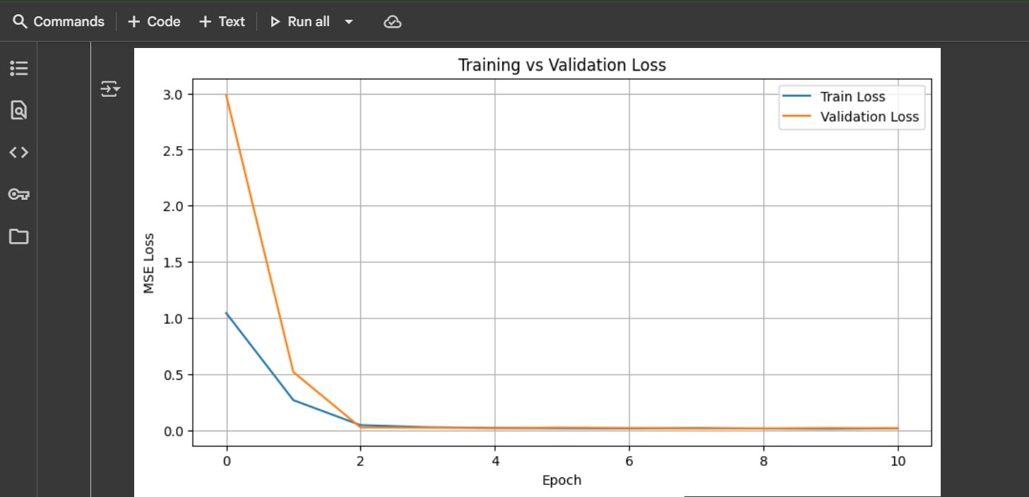  
• Predicted vs Actual Prices – Indicates accuracy of predictions.

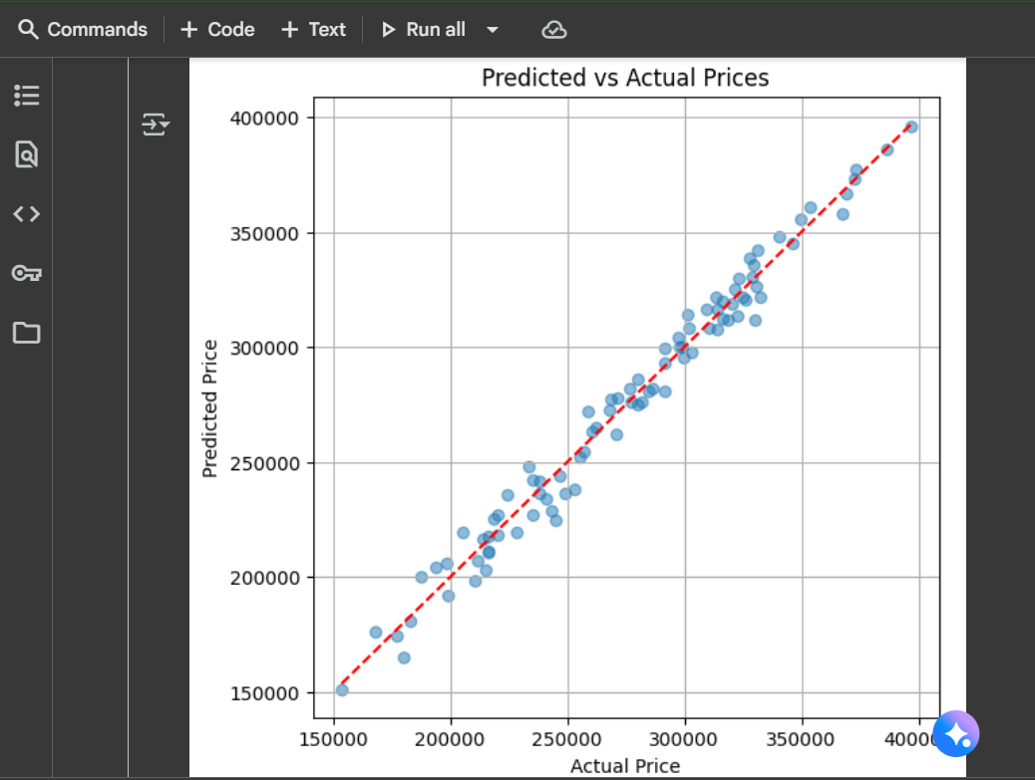  
• Prediction Error Distribution – Shows error spread around zero.

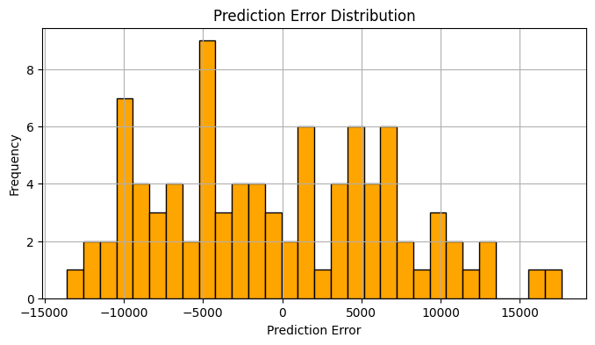

## 5. Interpretation of Results

The Prediction Error Distribution plot is centered around zero, indicating unbiased predictions. Most errors fall within ±10,000, demonstrating good accuracy and generalization. The model does not show systematic over- or under-prediction trends.

## 6. Conclusion

The model performs well on the synthetic dataset, with low error rates and balanced predictions. It can be considered reliable for price prediction tasks. Future improvements may include hyperparameter tuning, feature engineering, or model ensemble approaches for even higher accuracy.